|  |
| --- |
|  |
| Real-Time Traffic Monitoring and Analysis  CAI1_AIS4_S10d |
| |  |  |  | | --- | --- | --- | | Final report | 10/11/24 |  | |

**Team Members:**

|  |  |
| --- | --- |
| Name | Task |
| Gamal Sayed Ahmed | * Created database schema * Scripted post-Loading data-python (SQL Alchemy) * Scripted data-python (Analysis) * Machine Learning Modeling (Classification model) * Final report |
| Abdelrahman Adel Mohamed | * Loaded data into database (SSIS) * Created data warehouse schema (SSMS) * Azure services * Dashboard (power Bi) |
| Mahmoud Hamdy Mahmoud | * SQL queries (SSMS) * Created data warehouse schema (SSMS) * Azure Services * Presentation |
| Omar Ahmed Ayad | * SQL queries (SSMS) * Loaded data from database into data warehouse (SSIS) * Azure Services |
| Youssef Amr Said | * Scripted pre-processing data-python (cleaning) (Python) * Azure Services * Presentation |

1. **Week 1: SQL Database and Data Collection**

* Database Design:
* 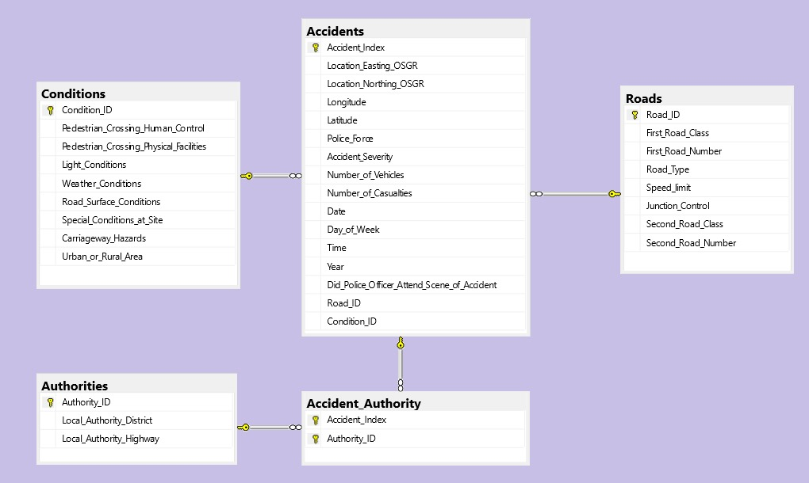Designed a SQL database schema for managing traffic data
* Data Collection:
* used real-time traffic data to populate the database from Kaggle [https://www.kaggle.com/datasets/silicon99/dft-accident-data/data]

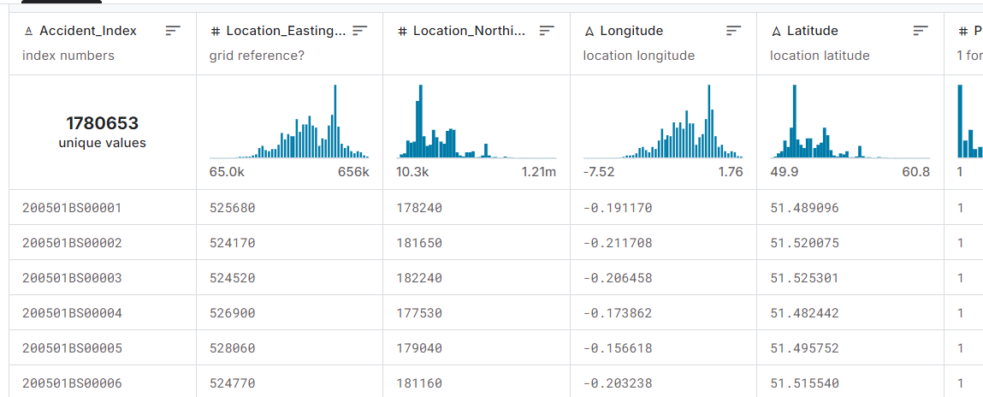

* 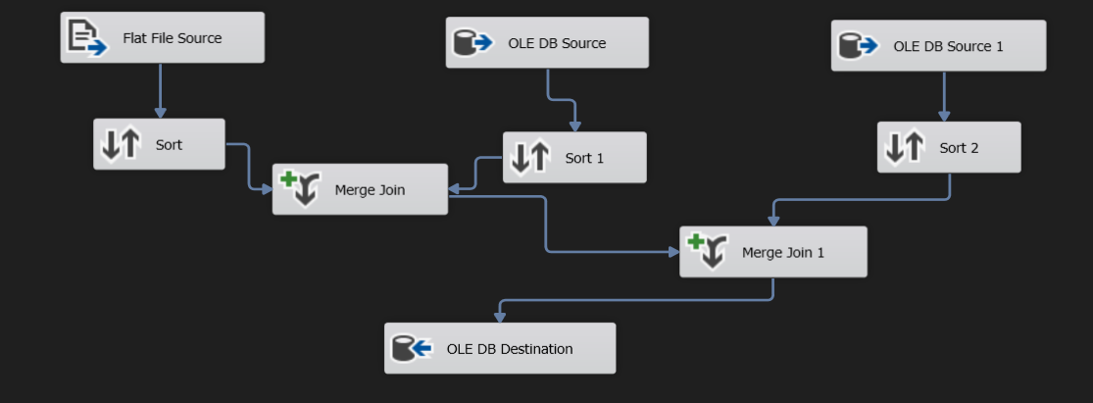used SSIS to load the data into the database
* 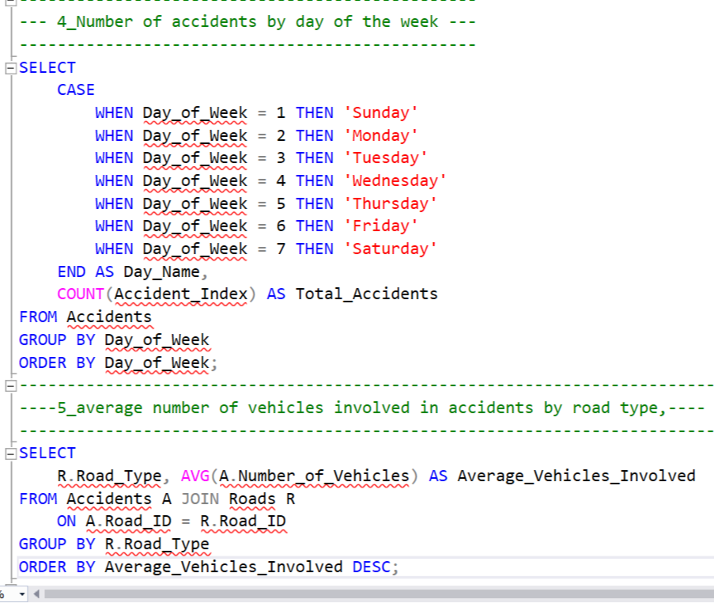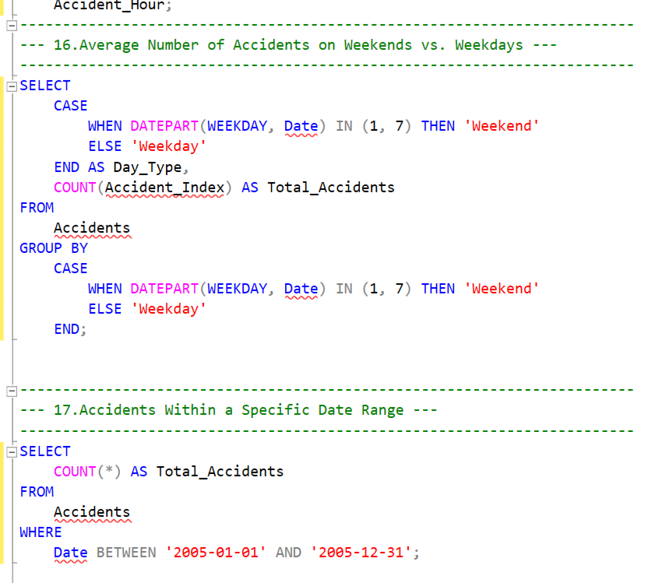SQL queries

**Tools used for week 1:**

|  |
| --- |
| Microsoft SQL Server |
| SQL Management Studio |

1. **Week 2: Data Warehouse and Python Integration**

* Data Warehouse:
* Implemented Data warehouse using Star Shema

* Time dimension table:

* A screenshot of a computer

  Description automatically generatedMeasures functions:

* 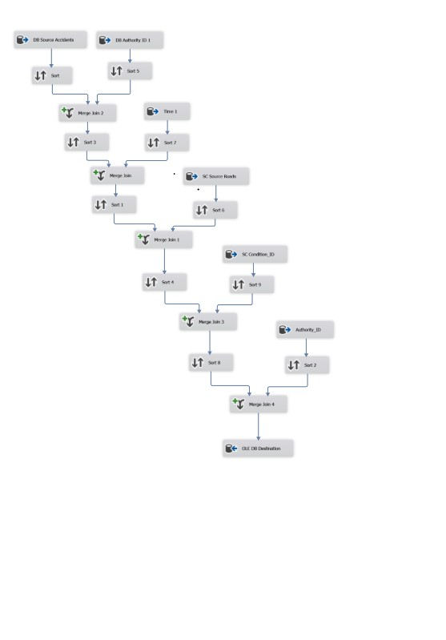Data Loading:
* Using SSIS:
* Fact table data loading
* Other Tables data loading:

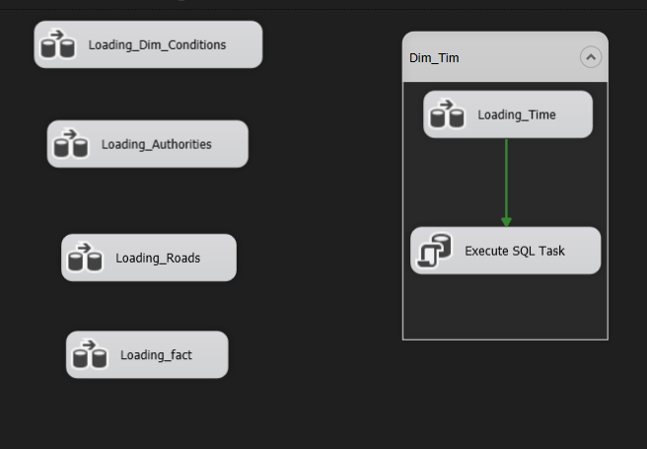

* Python Scripting:
* A screenshot of a computer

  Description automatically generatedPre-processing loading into database

* 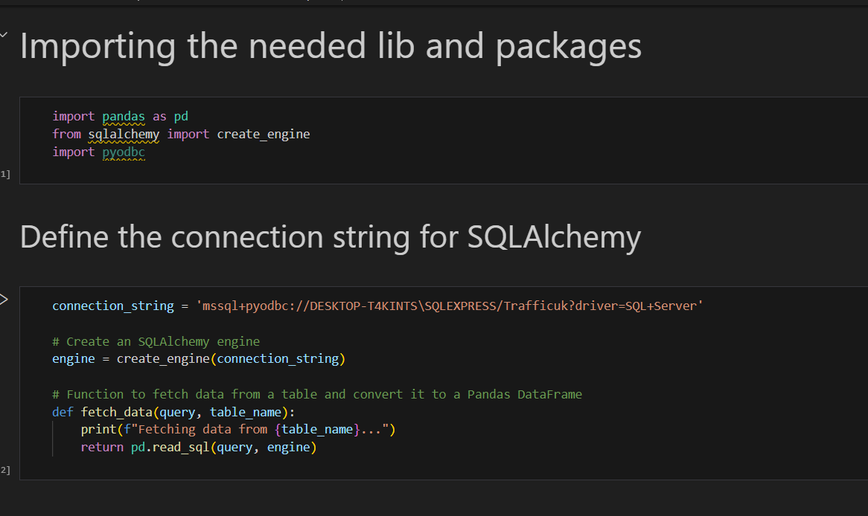Pos-processing loading from database into python

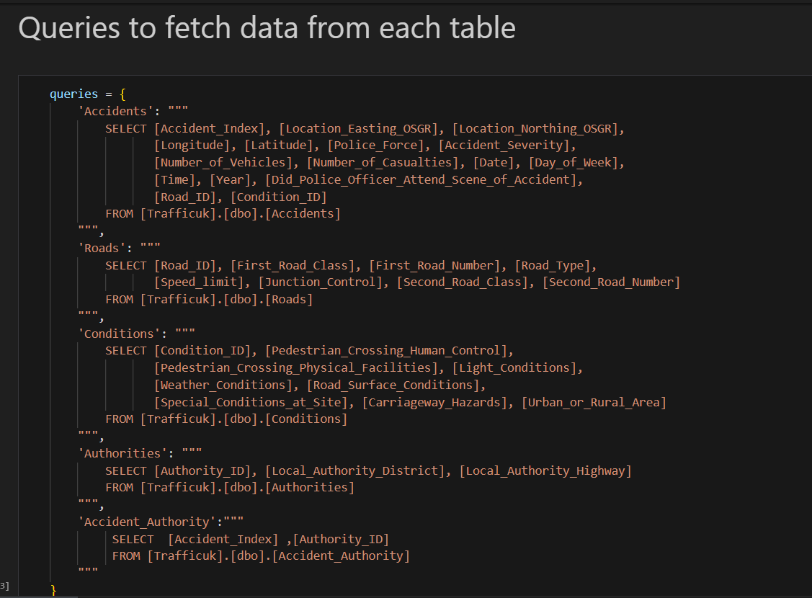

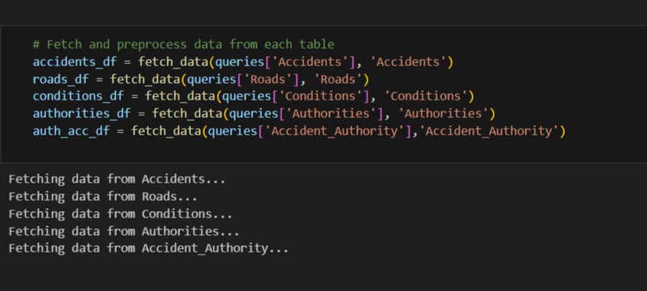

**Tools used for week 2:**

|  |
| --- |
| SSIS (visual studio for loading the data in the data warehouse) |
| SSMS (for implementing data warehouse) |
| Jupyter notebook (python: SQL Alchemy , pandas , NumPy) |

1. **Week 3: Traffic Analysis and Azure Services**

* 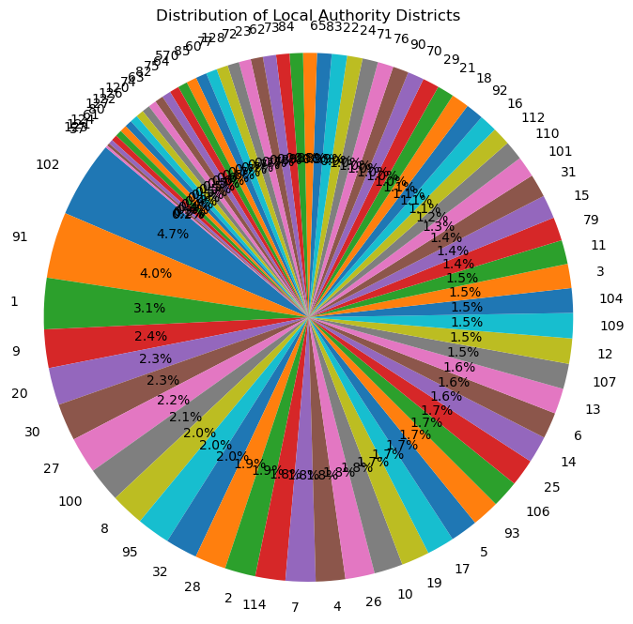Traffic Analysis:

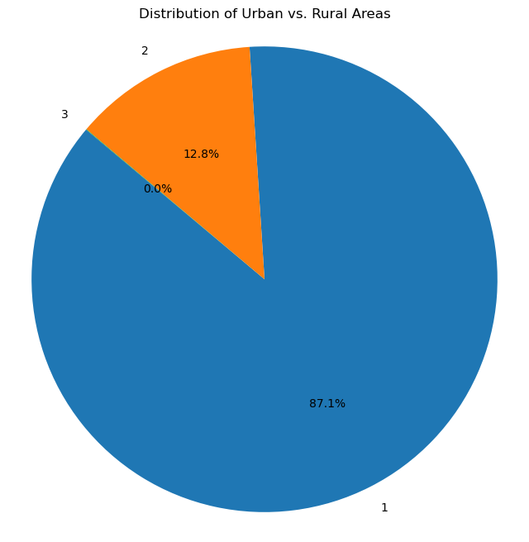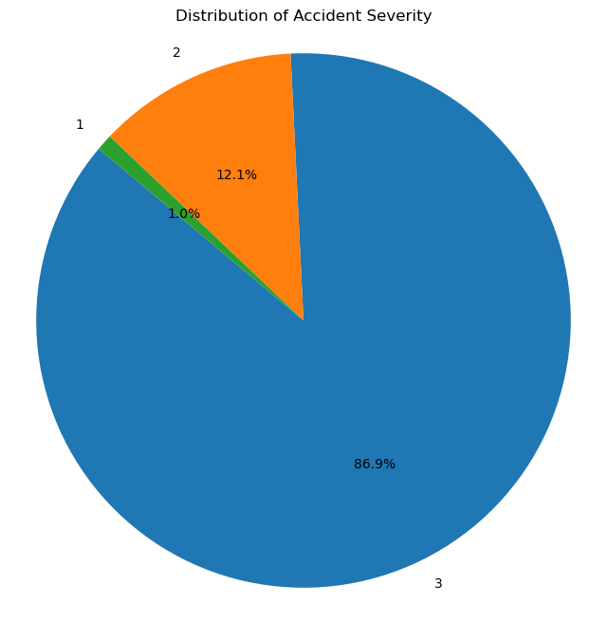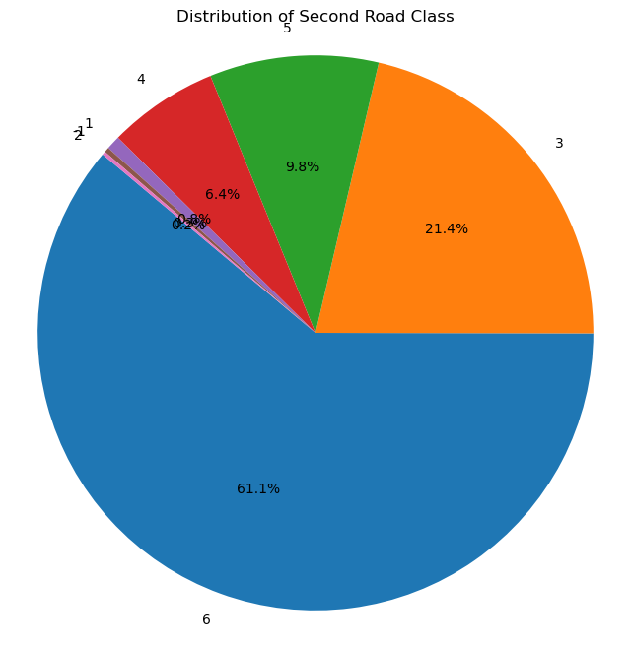

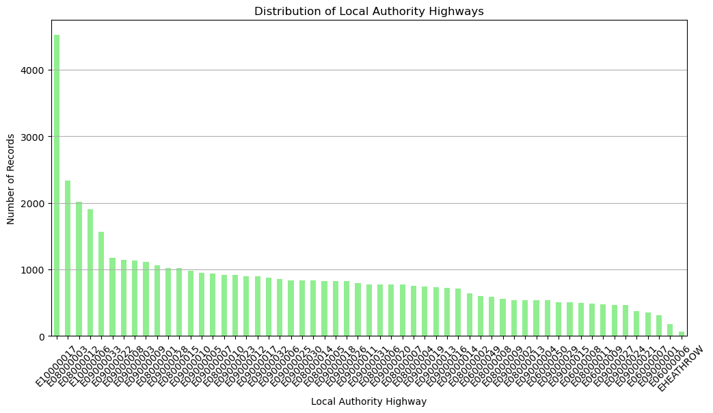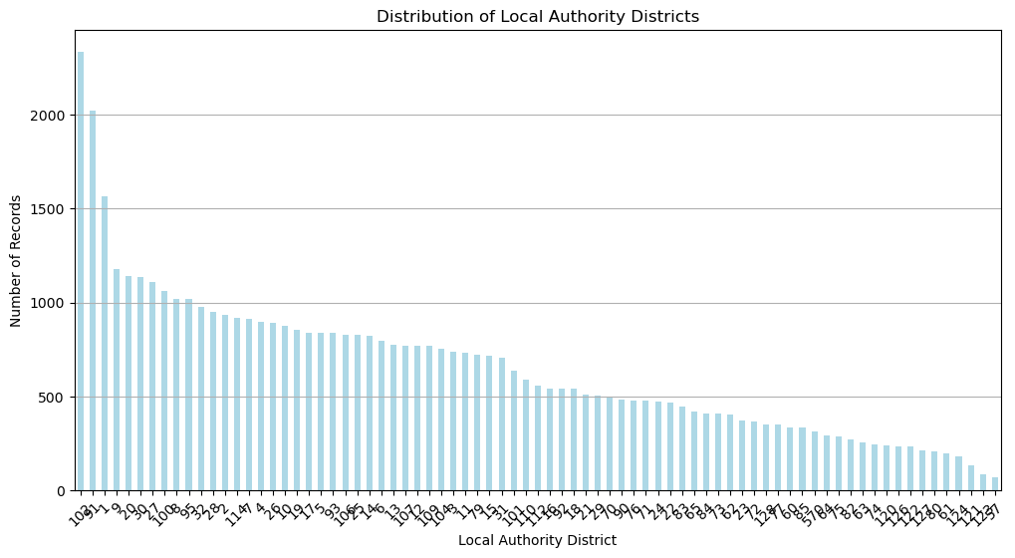

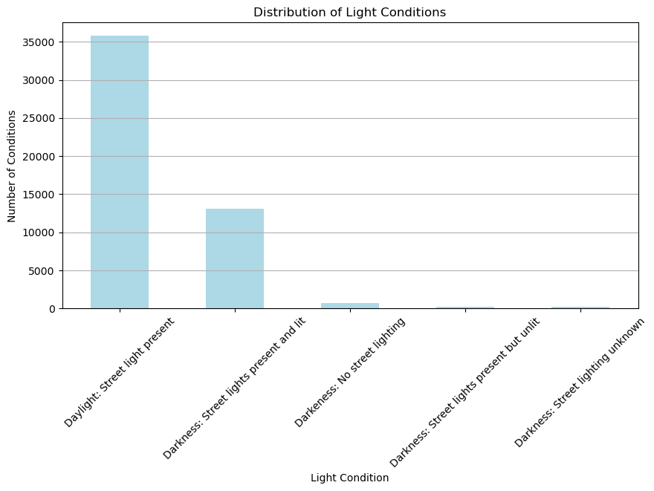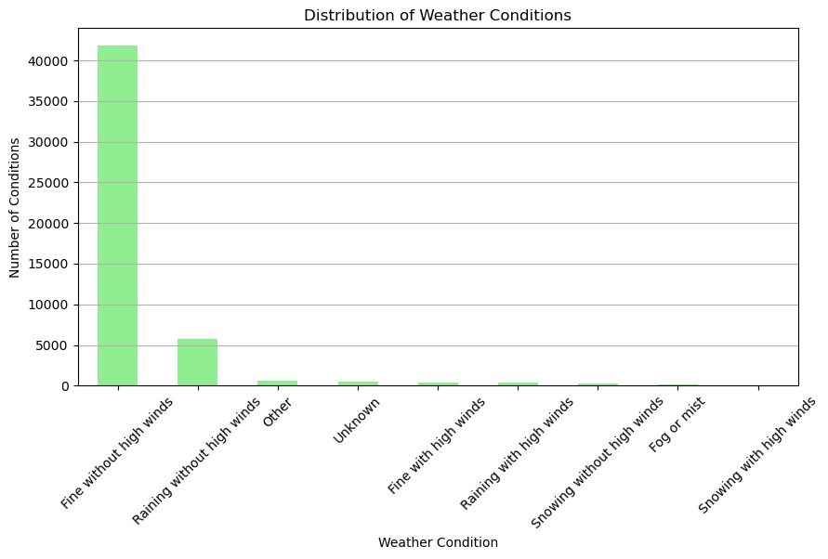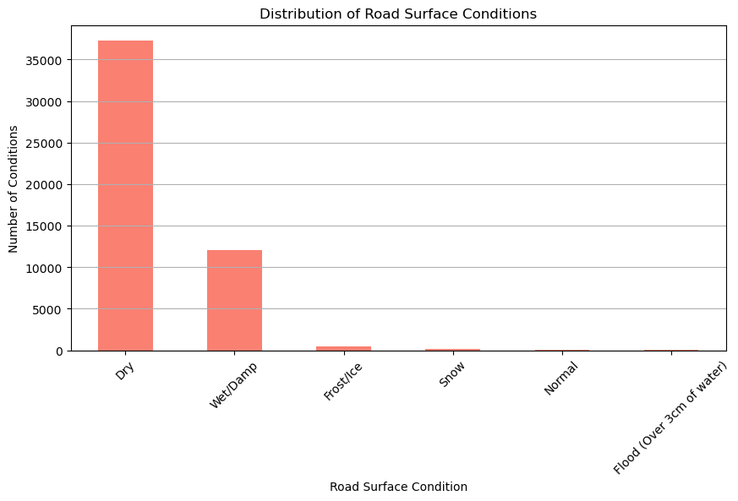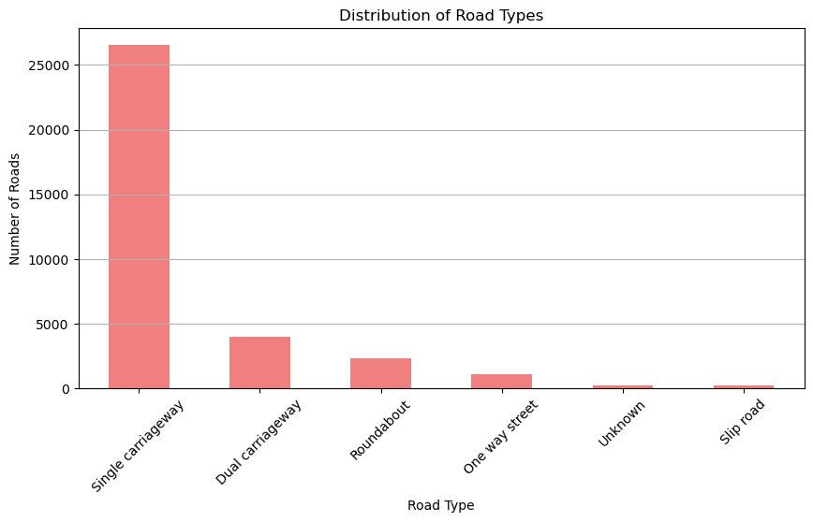

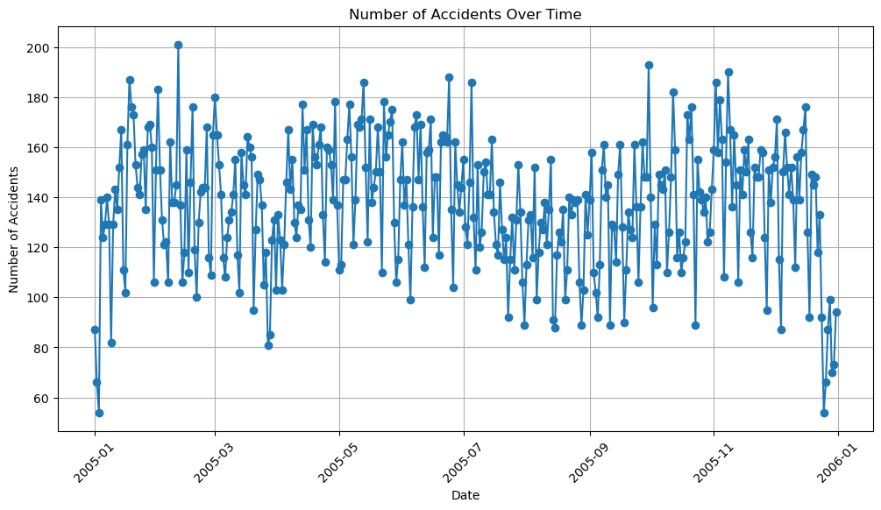

* A map of the united kingdom

  Description automatically generatedAccident distribution across UK:
* Model Development:
* Used random forest classification and logistic regression classification for classifying accidents severity with accuracy 87% each:

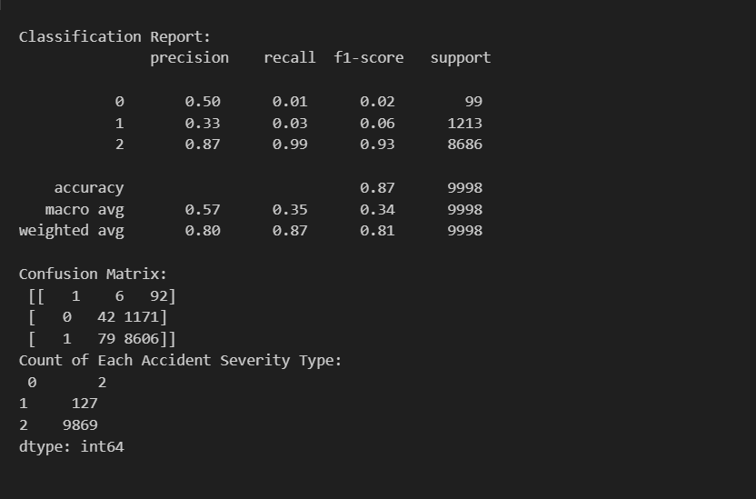

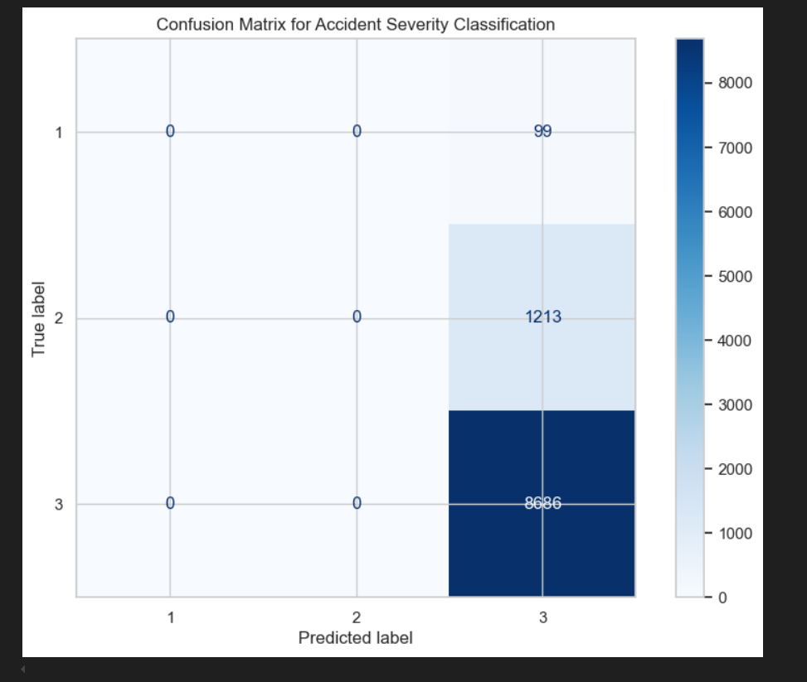

* 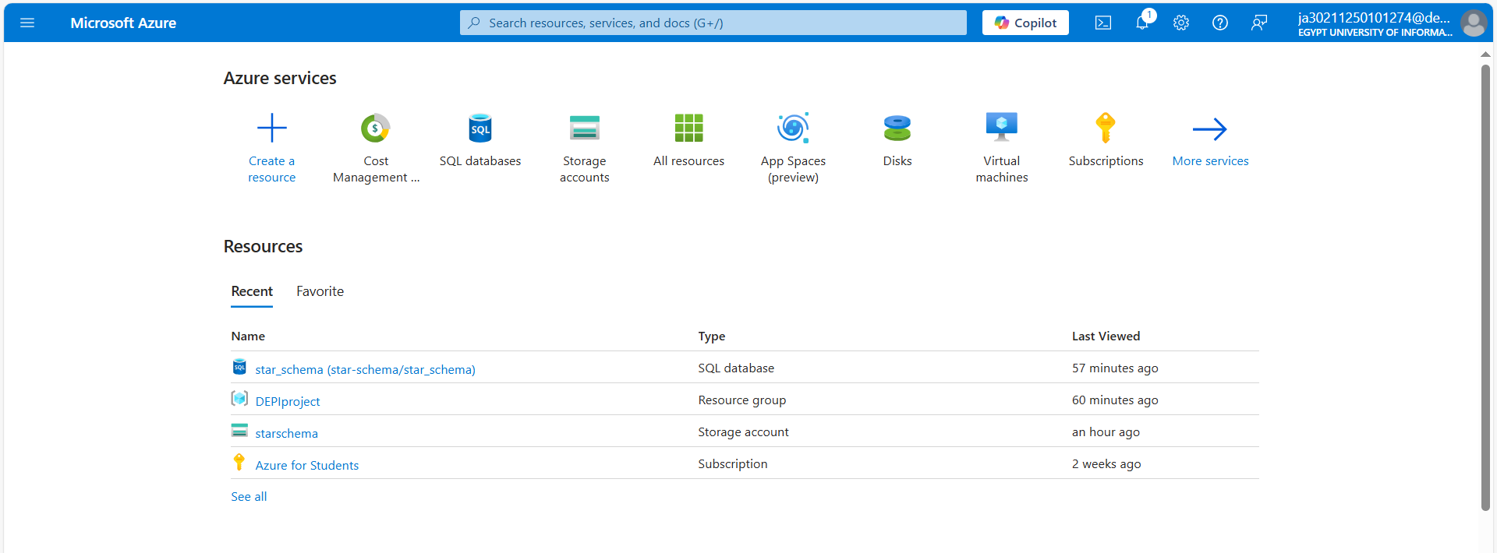Azure Services:

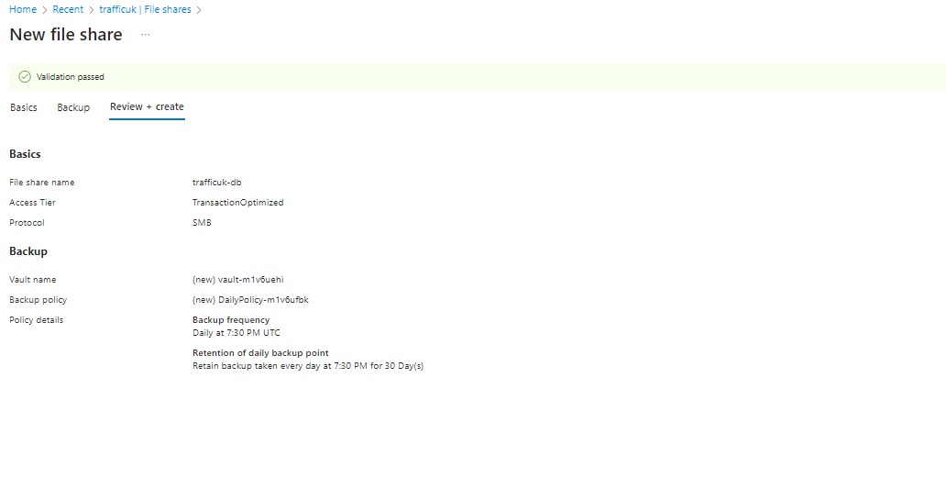

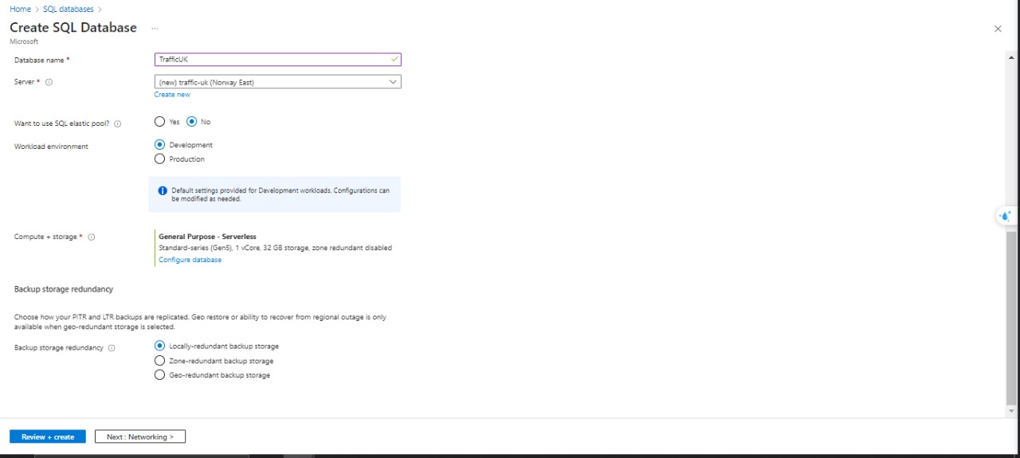

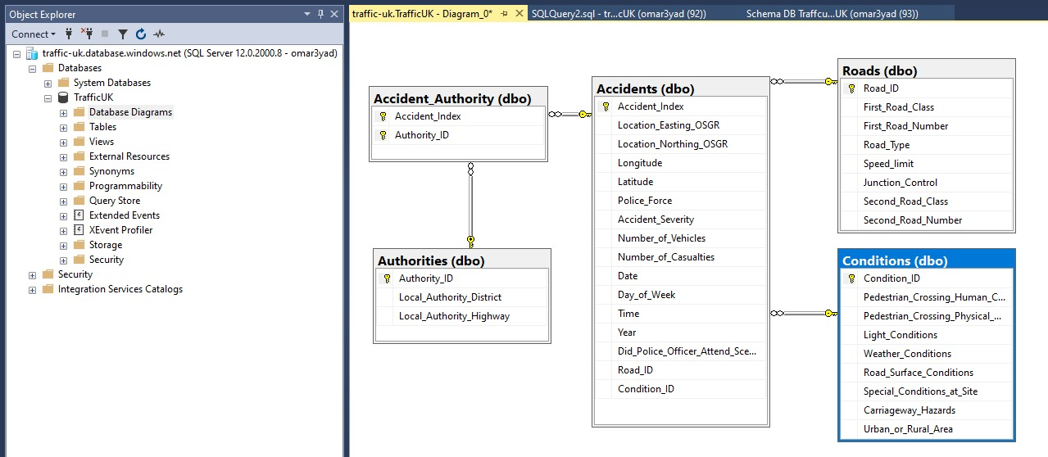

**Tools used for week 3:**

|  |
| --- |
| Azure different services |
| Machine learning algorithms |

1. **Week 4: and Deployment**

* 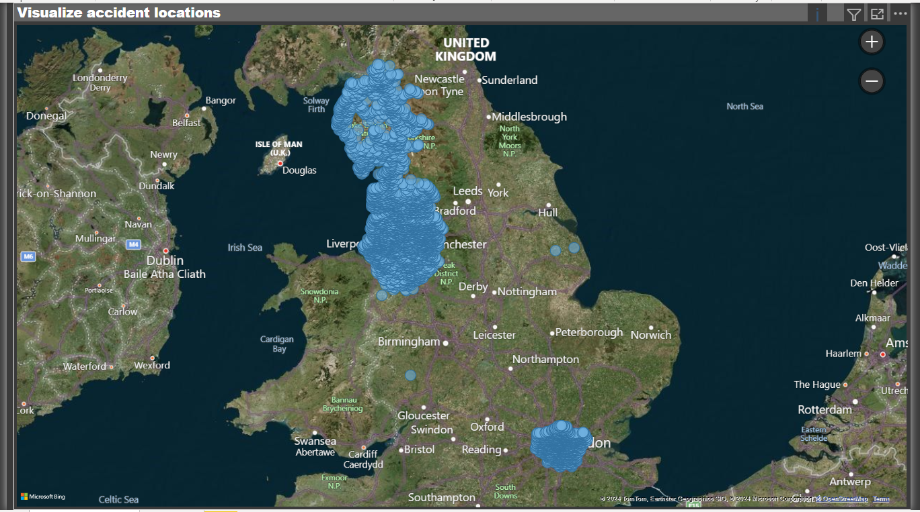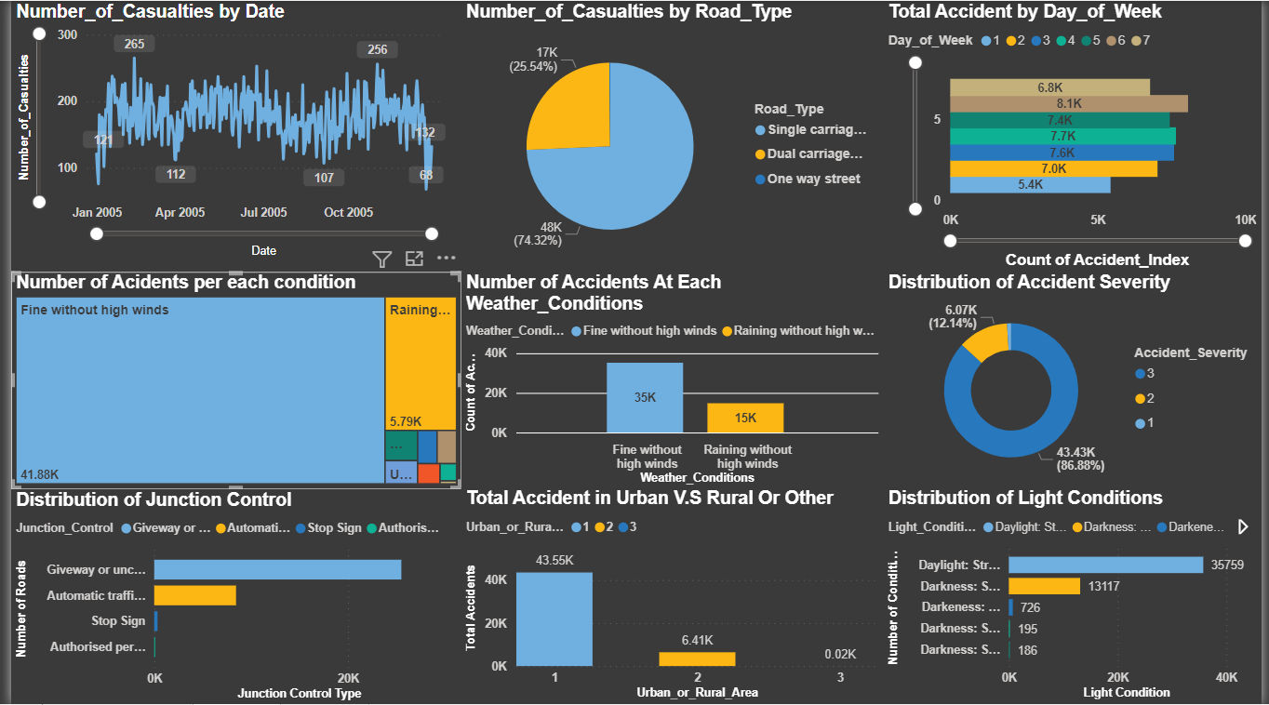Deployment: Dashboard

**Tools used for week 4:**

**Power bi for displaying the dashboard**